**NAME: AMITAB**

**ROLL NO: SFI-24S-028**

**LAB NO: 1**

**INTRODUCTION TO PYTHON :**

Python is a beginner-friendly programming language that's easy to learn and use. It’s popular because it has simple, readable code and can be used for many things, like building websites, analyzing data, or creating games. Python works on all major operating systems, like Windows and Mac, and it has many built-in tools (called libraries) to make your work easier.

Some key features of Python:

* Simple Syntax: The code looks like plain English, so it’s easy to understand.
* Versatile: You can use it for web development, data analysis, and more.
* Large Community: Many people use Python, so it's easy to find help online.

***TASK NO 1: Make 2-2 programs of each datatype.***

1. **NUMERIC TYPES**

**Integer (int) :**

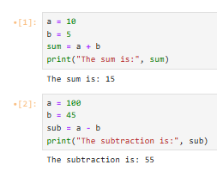

**Floating-point (float) :**

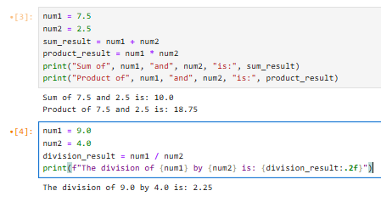

**Complex (complex) :**

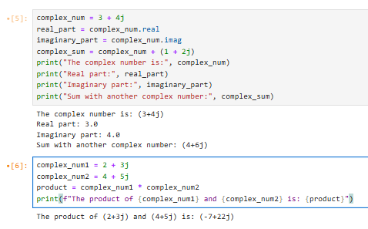

1. **Sequence Types**

**String (str) :**

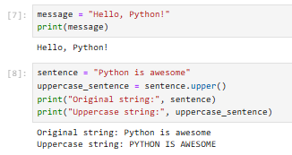

**List (list) :**

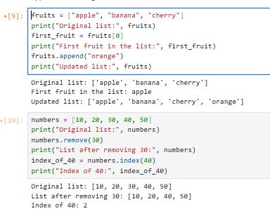

**Tuple (tuple) :**

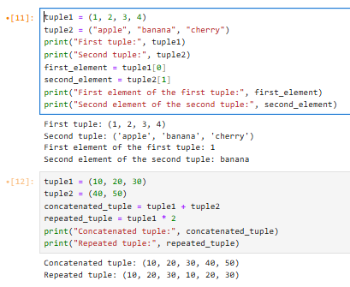

**Range (range) :**

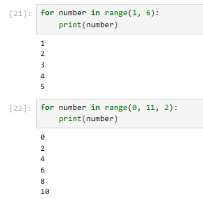

1. **SET TYPES**

**Set (set) :**

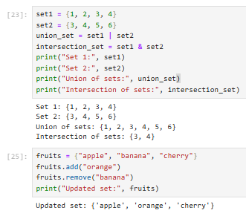

**Frozen Set (frozenset) :**

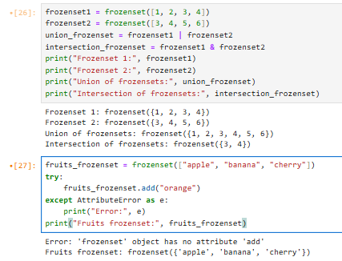

1. **MAPPING TYPE**

**Dictionary (dict) :**

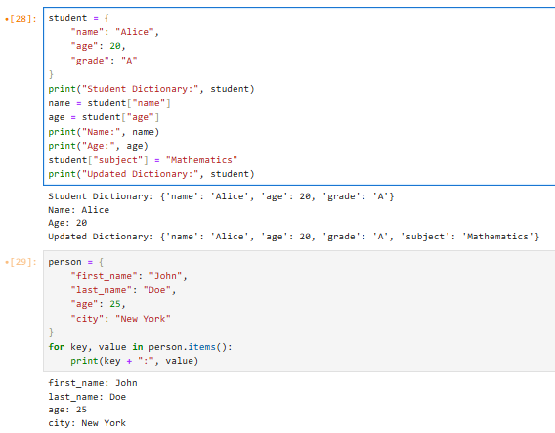

1. **Boolean Type**

**Boolean (bool) :**

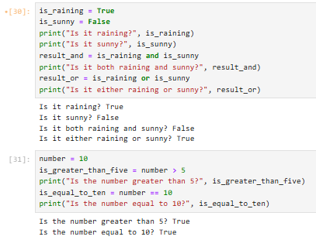

**TASK NO 2: Make up to 5 Shape programs using *.**

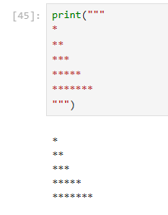

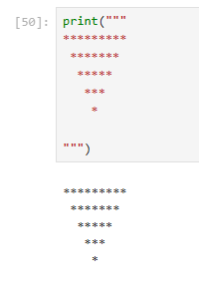

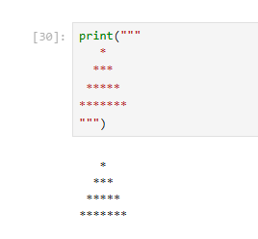

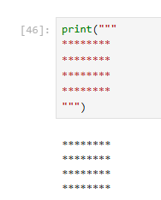

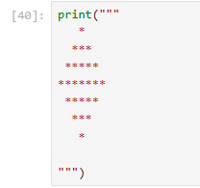

**TASK NO 3: Make same shapes you have made in task 2, using * mutiple by number.**

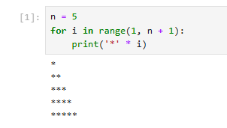

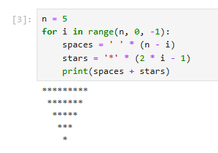

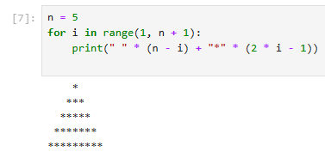

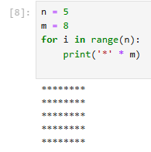

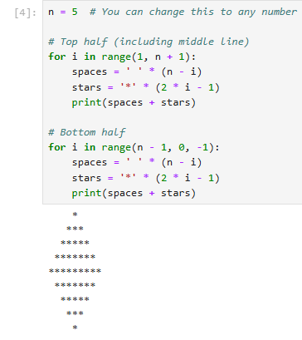

LAB NO: 2

**TASK NO 1: Print numbers from 1 to 10 using a for loop.**

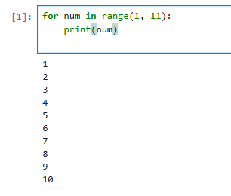

**TASK NO 2: Print all even numbers between 1 and 20 using a while loop.**

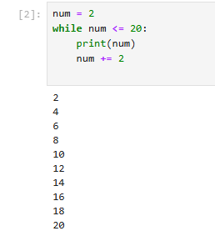

**TASK NO 3: Calculate the sum of numbers from 1 to 100 using a loop.**

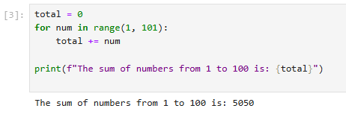

**TASK NO 4: Print the multiplication table of 5 using a loop.**

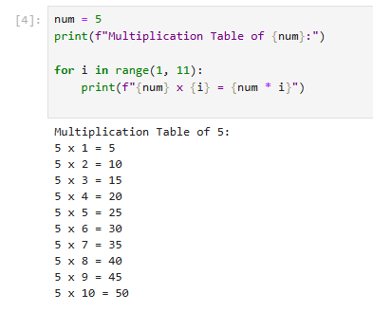

**TASK NO 5: Find the factorial of a given number using a for loop.**

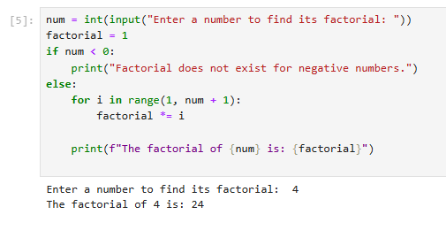

**TASK NO 6: Create a list of numbers and print only the odd numbers using a loop.**

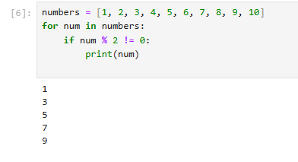

**TASK NO 7: Iterate over a list of fruits and print each item.**

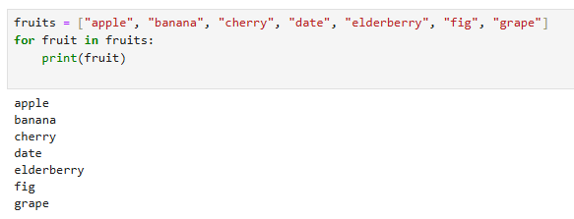

LAB NO: 4

**TASK NO 1: Write a Python program to take two numbers as input and perform all arithmetic operations on them.**

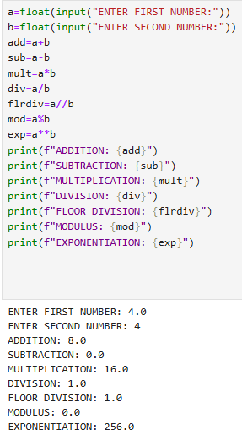

**TASK NO 2: Create a function that takes two numbers and returns their sum, difference, product, and quotient.**

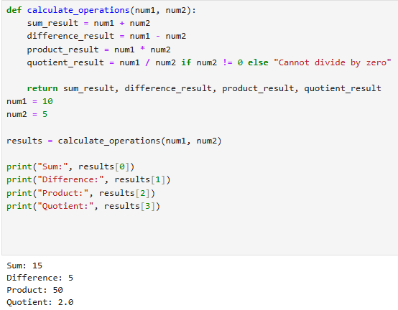

**TASK NO 3: Write a Python script to find the remainder when one number is divided by another.**

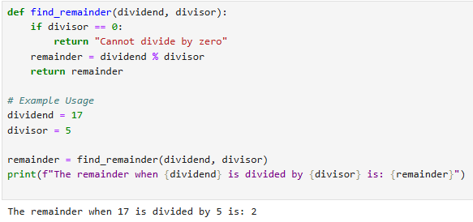

**TASK NO 4: Write a program to calculate the area of a circle using the formula: Area = π * r^2.**

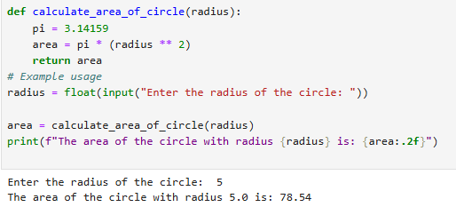

**TASK NO 5: Implement a program that takes a number as input and returns its square and cube using exponentiation.**

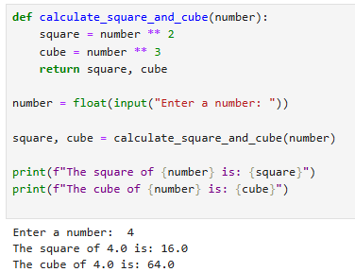

**TASK NO 6: Create a simple calculator in Python that allows the user to choose an operation (addition, subtraction, etc.) and inputs two numbers.**

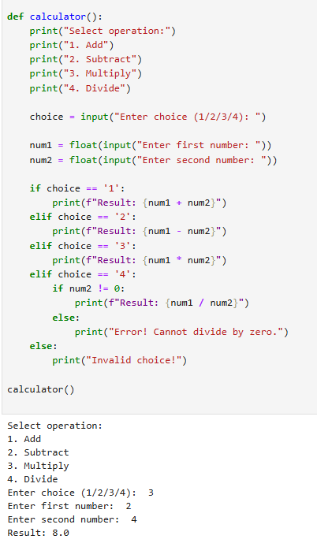

**LAB NO: 5**

**TASK NO 1: Basic Task: Write a program that checks if a given number is positive, negative, or zero.**

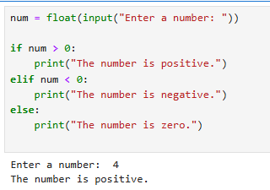

**TASK NO 2: Intermediate Task: Write a program that takes user input and determines whether it's a even or odd.**

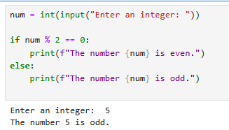

**TASK NO 3: Create a program that asks user to print:**

* **"Excellent" if marks are above 80**
* **"Good" if marks are between 60 and 80**
* **"Needs Improvement" if marks are below 60**

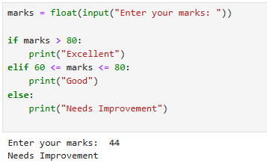

**LAB NO: 6**

**TASK NO 1: Write a while loop that prints numbers from 10 down to 1.**

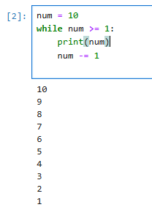

**TASK NO 2: Create a program that uses a for loop to iterate over a string and count the number of vowels.**

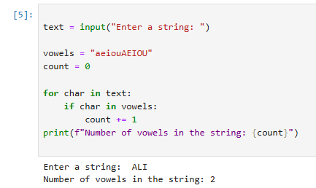

**TASK NO 3 :Write a program that prints the Fibonacci series up to n terms using a while loop**

